C:\Documents and Settings\greeki\Local Settings\Temporary Internet Files\Content.IE5\FUMA0N5O\MC900445926[1].wmfHabitat Survey

A habitat is the environment where an organism or population of organisms lives. In order for these organisms to survive and reproduce the habitat they occupy has to provide their basic requirements and suitable conditions.

*\\uahs3\apps\OFFICE MEDIA CONTENT\FILES\PFILES\MSOFFICE\MEDIA\CNTCD1\ClipArt2\j0229357.wmfWhat sort of things does an organism need from its habitat?*

Different organisms have different requirements and conditions under which they will survive. An ecosystem can provide a number of different habitats that can support different organisms. The number and variety of organisms which a habitat supports is called biodiversity.

*\\uahs3\apps\OFFICE MEDIA CONTENT\FILES\PFILES\MSOFFICE\MEDIA\CNTCD1\ClipArt2\j0229357.wmfIn terms of biodiversity, what would you expect to find in an ecosystem that has a number of different habitats? Why is this important?*

Freshwater environments, such as wetlands and rivers, are examples of ecosystems that provide a number of different habitats. These habitats vary along the water course due to factors including water flow, topography, soils, and human impact. **Your task today is to assess the quality of the wetland habitats at several different locations by observing a number of different factors that are described below. Once you have assessed these factors you will use your results to decide on the overall health of the wetland.**

**Habitat Factors**

Freshwater habitats are often divided into different zones to make studying them easier. You will be examining factors in 2 main zones today; the riparian zone & the in-stream zone.

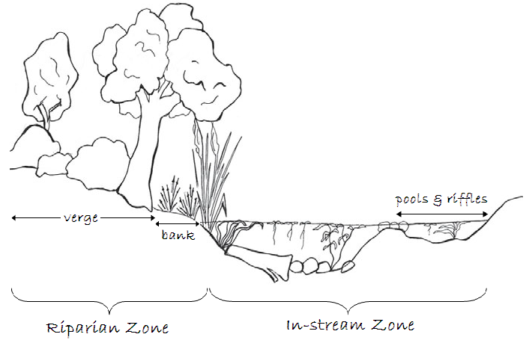**The Riparian Zone**

* Area where terrestrial &aquatic habitats meet
* Acts as a wind break, a filter for runoff & a corridor for wildlife
* Includes verge vegetation & bank vegetation

**The In-stream Zone**

* Includes the water and the features within it
* Features can include plants, pools, bends, riffles, islands, rocks, logs 9above the water) & snags (below the water).

**C:\Documents and Settings\greeki\Local Settings\Temporary Internet Files\Content.IE5\8K517XP1\MC900335436[1].wmfHabitat Assessment Table:** habitat factors & how to assess them

|  |  |  |  |  |  |
| --- | --- | --- | --- | --- | --- |
|  | **Riparian Zone** | | | **In-stream Zone** | |
| **Verge vegetation** | **Bank vegetation** | **Bank erosion & stability** | **In-stream Cover** | **Riffles, pools & bends** |
| ***Description*** | *Any vegetation growing within 30m of the bank* | *Trees, shrubs, grasses & reeds growing on the bank* | *Areas of the bank that have been destabilised or worn away* | *Aquatic plants, rocks, snags, logs etc that provide shelter, nurseries etc* | *Shallow areas where water moves quickly (riffle), areas of varying flow, changes in bank contours* |
| **Excellent** | Mainly undisturbed native vegetation, verge 30m wide or more  **10** | Mainly undisturbed native vegetation. No signs of site alteration  **10** | Stable, no erosion or undercutting of bank, lots of vegetation cover  **5** | Abundant cover, frequent snags, logs etc with extensive areas of in-stream/over-hanging veg  **10** | Wide variations to water flow, depth & bank contours  **5** |
| **Good** | Mainly native vegetation, some introduced species, wide verge but less than 30m  **8** | Mainly native vegetation, little disturbance or no signs of recent disturbance  **8** | Only small spots of erosion present with little to no undercutting, lots of vegetation cover  **4** | Good coverage of snags, logs & boulders with considerable areas of aquatic vegetation and overhanging vegetation  **8** | Good variations to water flow, depth & bank contours  **4** |
| **Fair** | Wide verge. Mix of natives & introduced species, some clearing  **6** | Medium cover, mixed native & introduced, some signs of disturbance  **6** | Localised erosion but no continuous damage, some vegetation cover  **3** | Some snags or boulders and/or occasional areas of vegetation  **6** | Some variations to water flow, depth & bank contours  **3** |
| **Poor** | Narrow verge with few natives  **4** | Predominantly introduced species with few natives, signs of disturbance  **4** | Significant active erosion with little vegetation cover  **2** | Only slight cover with occasional snags and very little vegetation  **4** | Only slight variations to water flow, depth & bank contours  **2** |
| **Very poor** | Bare ground or introduced grasses with no trees  **2** | Introduced species with few trees, obvious signs of disturbance or no natural bank  **2** | Extensive erosion and/or undercutting with little vegetation cover  **1** | No cover, no snags or boulders, no vegetation, site may have concrete lining  **2** | No variations to water flow, depth or bank contours  **1** |

**\\uahs3\apps\OFFICE MEDIA CONTENT\FILES\PFILES\MSOFFICE\MEDIA\CNTCD1\ClipArt3\j0235259.wmfC:\Documents and Settings\greeki\Local Settings\Temporary Internet Files\Content.IE5\FUMA0N5O\MC900022467[1].wmf Method**

1. Assign one member of your group to be the recorder. This person will need to collect a clipboard & record sheet and then record everything when you are in the field.
2. Use the map below to navigate to one of the 4 locations you need to asses but remember **ALL your observations MUST be made from a SAFE location such as a sturdy bank, jetty or boardwalk**.
3. Once you reach your first location, carefully observe the factors shown in the ‘General Observations’ section of the results table and then record your observations.
4. After you have made your observations, use the Habitat Assessment table to assess the riparian zone and in-stream zone.
5. Record your scores for this in the ‘Habitat Assessment’ section of the results table and then give the location a total score out of 40.
6. Repeat steps 2 – 6 until you have studied all 4 sites. (Locations don’t have to be done in order)

**Location Details**

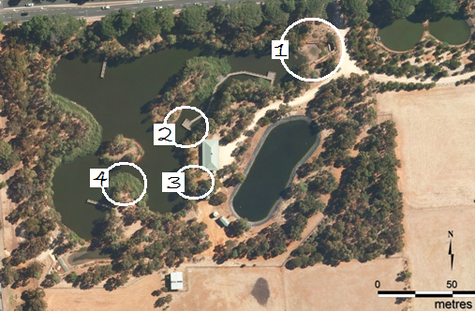

|  |  |  |
| --- | --- | --- |
| **Location** | **Name** | **Observation point** |
| **1** | Cross Road inlet | Stand on the southern bank and observe both sides of the inlet from the trash racks to the end of the boardwalk |
| **2** | Boardwalk | Stand on the viewing platform and observe everything within a 10 metre radius, including the island bank |
| **3** | Learning centre | Observe the bank and associated water and inland area between the learning centre and the friends cabin to the south (don’t include and land on the other side of the water) |
| **4** | Ephemeral zone | Stand on the point of the ephemeral zone and observe everything within that area, including the island bank opposite the point. You won’t be able to access the bank but you can use the jetty to get a different view |

**\\uahs3\apps\OFFICE MEDIA CONTENT\FILES\PFILES\MSOFFICE\MEDIA\CNTCD1\ClipArt4\j0251195.wmfResults**

|  |  |  |  |  |
| --- | --- | --- | --- | --- |
|  | **Locations** | | | |
| **General Observations** |  |  |  |  |
| *Topography* |  |  |  |  |
| *Type of vegetation* |  |  |  |  |
| *Level of vegetation cover* |  |  |  |  |
| *Animals* |  |  |  |  |
| *General comments (smells, sounds, comparison to other site)* |  |  |  |  |
| **Habitat Assessment** | | | | |
| *Verge vegetation* ***/10*** |  |  |  |  |
| *Bank vegetation* ***/10*** |  |  |  |  |
| *Bank erosion & stability*  ***/5*** |  |  |  |  |
| *In-stream cover*  ***/10*** |  |  |  |  |
| *Riffles, pools & bends*  ***/5*** |  |  |  |  |
| ***Habitat Quality***  ***/40*** |  |  |  |  |

**\\uahs3\apps\OFFICE MEDIA CONTENT\FILES\PFILES\MSOFFICE\MEDIA\CNTCD1\ClipArt3\j0236650.wmfConclusions**

Based on your results, which locations do you think had the best habitat? Discuss all 4 locations and use specific examples from your results to justify your response

**\\uahs3\apps\OFFICE MEDIA CONTENT\FILES\PFILES\MSOFFICE\MEDIA\CNTCD1\ClipArt2\j0229369.wmf**

**Questions**

(select the ones relevant to your class and then delete the rest or feel free to add in your own)

* Pick 2 locations that you studied that you thought were very different. Compare the habitat in each one and predict what you think you would find if you surveyed the animals (from macroinvertebrates to birds) that live there. Include specific examples from your results and explain why you made the prediction you did
* In your results table you recorded two lots of results, one was general observations while the other was the scores you gave each habitat factor. Do you think you would have reached the same conclusion about which location was the best using just your general observations? Justify your response with specific examples from your results.
* What problems do you see with using a matrix like the habitat assessment table to assess something like habitat quality? How could you overcome these problems? (Assume you had unlimited time and more high tech resources)
* Why do you think the vegetation factors and in-stream cover are worth more marks in the habitat quality score than the other factors?
* Why is it important to have a variety of habitats within a certain area?
* Do you think the Urrbrae Wetland is ‘healthy’? Use specific examples from your results to justify your response.
* Two of the most common groups of organisms at the wetland are aquatic macroinvertebrates & birds. Which group do you think would be more sensitive to habitat change at the wetland? Why?
* C:\Documents and Settings\greeki\Local Settings\Temporary Internet Files\Content.IE5\GEGNQFVN\MC900335190[1].wmfIf our main concern is the wetland, why do we have to worry about vegetation 30 meters away from the water?
* Do you think the riparian zone and the in-stream zone are 2 separate zones or are they linked in some way? Explain your answer using some of the observations you made during this activity.
* If you had to rehabilitate a natural water way such as a river or a wetland what sort of an area would your create and why? You can describe what you would do or draw it but use examples from your results to illustrate your ideas.