An Introduction to the Urrbrae Wetland

The Urrbrae Wetland project was one of the first urban wetland developments within close range of residential areas to be attempted in Australia. The successful integration of the Urrbrae Wetland wild, aquatic and plant life within an urban environment has created a widely used example and reference point for the future use of wetlands across the world. It now provides exciting opportunities for the education of the thousands of school children as well as the wider community including local, national and international organisations.

### The Function of the Urrbrae Wetland

The Urrbrae Wetland began life as an idea that the City of Mitcham and Urrbrae Agricultural High School generated separately from one another. When both parties realised that were considering similar project they joined forces and the wetland was born. It was designed and built to **reduce flooding** in the local area and **clean up storm water** and while it only covers an area of approximately 6 hectares its catchment area is around 380 hectares. Any drop of water that falls in this area could potentially end up in the wetland along with many different pollutants that it can pick up along the way. Previously this water and its pollutants may have flooded areas like Unley High School or Cross Road and would have then flowed out to sea but the wetland helps prevent this.

|  |  |
| --- | --- |
| **Function** | **How the wetland achieves it** |
| Flood prevention | Storing up to 17.7 million litres |
| Removing large, solid wastes, e.g rubbish, leaves etc | Trash racks |
| Removing sand, silt & other suspended solids | Slowing water to allow sedimentation to occur |
| Removing excess chemicals & pollutants | Pollutants attach to sediments and fall to the bottom  Pollutants are filtered out of the water by plants including reeds and sedges; |
| Removal of pathogens (bacteria & viruses) | Killed by ultra violet radiation from the sun  Consumed by Zooplankton |

### Building the Wetland

In July 1993, the Mitcham City Council carried out a study of the stormwater drainage system along Cross Road. Two large pipe systems join into a single pipe under Cross Road and the stormwater flows into the Patawalonga outlet and then into St Vincent Gulf at Glenelg. Due to increasing areas of hard surfaces like roads, rooves and paved areas the volume of stormwater flowing through this system was too large for the pipe system. As a result it was decided that a water detention should be constructed by diverting the water from the two inlet pipes into the Urrbrae Wetland, with an outlet pipe delivering the overflow water from the Wetland into the existing stormwater pipe under Cross Road.

Funds to build the Wetland were provided by the City of Mitcham, Department of Transport and the Patawalonga Catchment Board. The land itself is part of Urrbrae Agricultural High School as is owned by them and DECS. The facility is currently managed by the City of Mitcham with Urrbrae Agricultural High School managing the education side and a volunteer group call the Friends of the Urrbrae Wetland manages the vegetation and day to day maintenance. With the cooperation of these groups the Wetland was opened on April 9th 1997.

### Wetland Design

The Urrbrae Wetland is a man made, permanent wetland with some ephemeral ponds in the surrounding areas. These ephemeral ponds demonstrate what a more natural wetland would be like because they often dry out during summer. The wetland itself has 4 main areas of water including the main pond, the two sedimentation ponds and the farm dam. These areas can be anywhere up to 3m deep when the wetland is full and each one helps the wetland function effectively as a flood controller and a storm water filter but this hasn’t always been the case.

When the wetland was first built the sedimentation ponds were not included and the stormwater ran straight into the main pond. Students from Urrbrae Agricultural High School were surveying the wetlands depth along set transects and they discovered that the maximum depth had gone from 3m to 2m in under 5 years. As a result of their findings the sedimentation ponds were added in 2003.

As well as controlling and cleaning stormwater the Urrbrae Wetland also provides invaluable habitat for a wide variety of animals including over 50 species of birds. These animals are able to find refuge in their urban surroundings because the wetland is planted with over 100 different species that are considered ‘local’ or endemic to the area, that is they are believed to have grown in the area prior to European settlement in 1836. The overall landscape is one of a native bushland containing tall trees, shrubs, grasses, shoreline plants and water plants.

|  |  |
| --- | --- |
| **Feature** | **Function** |
| Trash racks | Installed at each of the two inlet pipes, these trash racks filter the stormwater before it enters the sedimentation ponds. They collect leaves, silt, plastics and general rubbish and prevent them from entering the rest of the wetland. |
| Sedimentation ponds | There are two sedimentation ponds located at each of the inlets. The Cross Road sedimentation pond receives most of the polluted stormwater and its depth profile is formed into two deep water ponds partly separated from each other by a shallow ‘sand bar’. This has the effect of slowing the incoming water twice, thereby allowing time for the sediments to fall to the bottom of each deep pond area. The Kitchener Street pond is a smaller version of the Cross Road one. Both ponds have been engineered to allow heavy vehicle access so that the sediments can be removed from the ponds as required. |
| The main pond | The shape of the banks slows down the speed of the water to allow sediments to fall out of the water and into the bottom of each pond or into the plants growing in the wetland and along its edges |
| Reed banks | Banks of *Phragmities Australis* have been planted around the wetlands to slow down the water and help the sedimentation process. They also help to remove some of the chemicals including nitrates and phosphates from the water. |
| Boardwalk & jetties | Allows observation and water sampling from a variety of sites |
| The farm dam | Collects overflow water from the main pond and stores it. When the level in the main pond drops below a certain level the water can be pumped back. This is important because the main pond is lined with clay which can dry out and crack if it is exposed by low water levels. This would allow seepage of polluted water into underground water supplies so the clay must be kept wet at all times. The farm dam is lined with plastic so it doesn’t have this problem. |

**Future use of the Urrbrae wetland**

The CSIRO Land and Water Centre at the Waite research Institute has investigated the possibility of storing some of the wetland water in the aquifer system. This involves pumping water underground but the layers of clay which exist along the foothills of the Mt. Lofty Ranges make this difficult because biolfilms (layers of bacteria, viruses and organic chemicals) stick to the clay and from a barrier that blocks the flow of water. More research is needed in this area to overcome these problems. In addition, Urrbrae Agricultural School may also investigate the reuse of excess water from the Wetland for irrigation purposes.

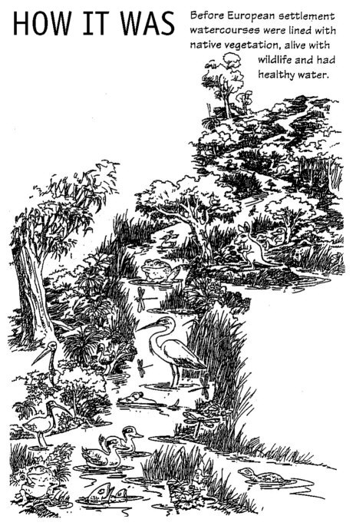**Catchments**

Catchments are areas of land that have either a natural or artificial slope towards one specific area. As water naturally runs down hill, the main idea behind catchment areas is that they collect the water and channel it through various paths until it ultimately collects at a low point within the catchment like lakes, rivers and their wetlands or eventually the sea.

In nature, rain is channelled by natural structures such as hills and mountains into small creeks that merge into larger waterways, which can then drain into the ocean.

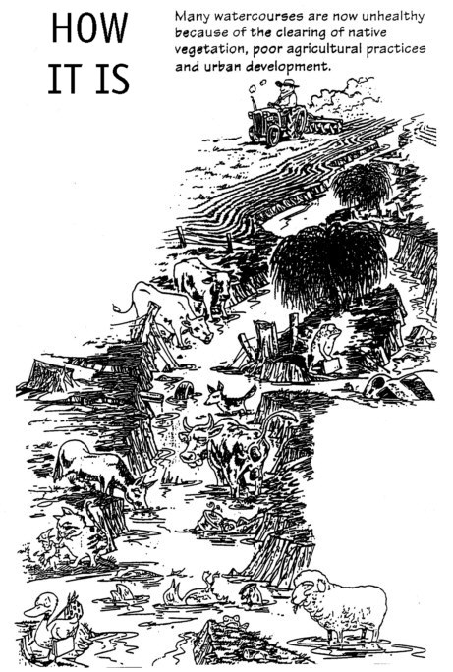In a city, the local council builds gutters to collect storm water and runoff. This water is channelled downhill through drains, creeks, swamps or even wetlands until it reaches the low point it was directed towards.

In the case of our Wetland, it is the low point of a small catchment area known as the Urrbrae Wetlands Catchment. Any drop of stormwater from this area will eventually run into the wetlands. However, the water from the Wetland drains into a larger catchment area for Brownhill Creek, which is part of the Patawalonga catchment. The following maps show the location of our Wetland in relation to these catchment areas. They also help you understand how catchments are connected.

Issues such as rainfall, pollution and water usage within a catchment area can have a significant impact on the quality of the water within the catchment. The quality of the water can then affect the flora (plants) and fauna (animals including humans) within the catchment. The investigations you will be doing throughout this unit will not only help us assess the health of our wetlands but also explore issues within out catchment area, such as pollution or whether we should construct more wetlands.

The next page has maps of our catchment.

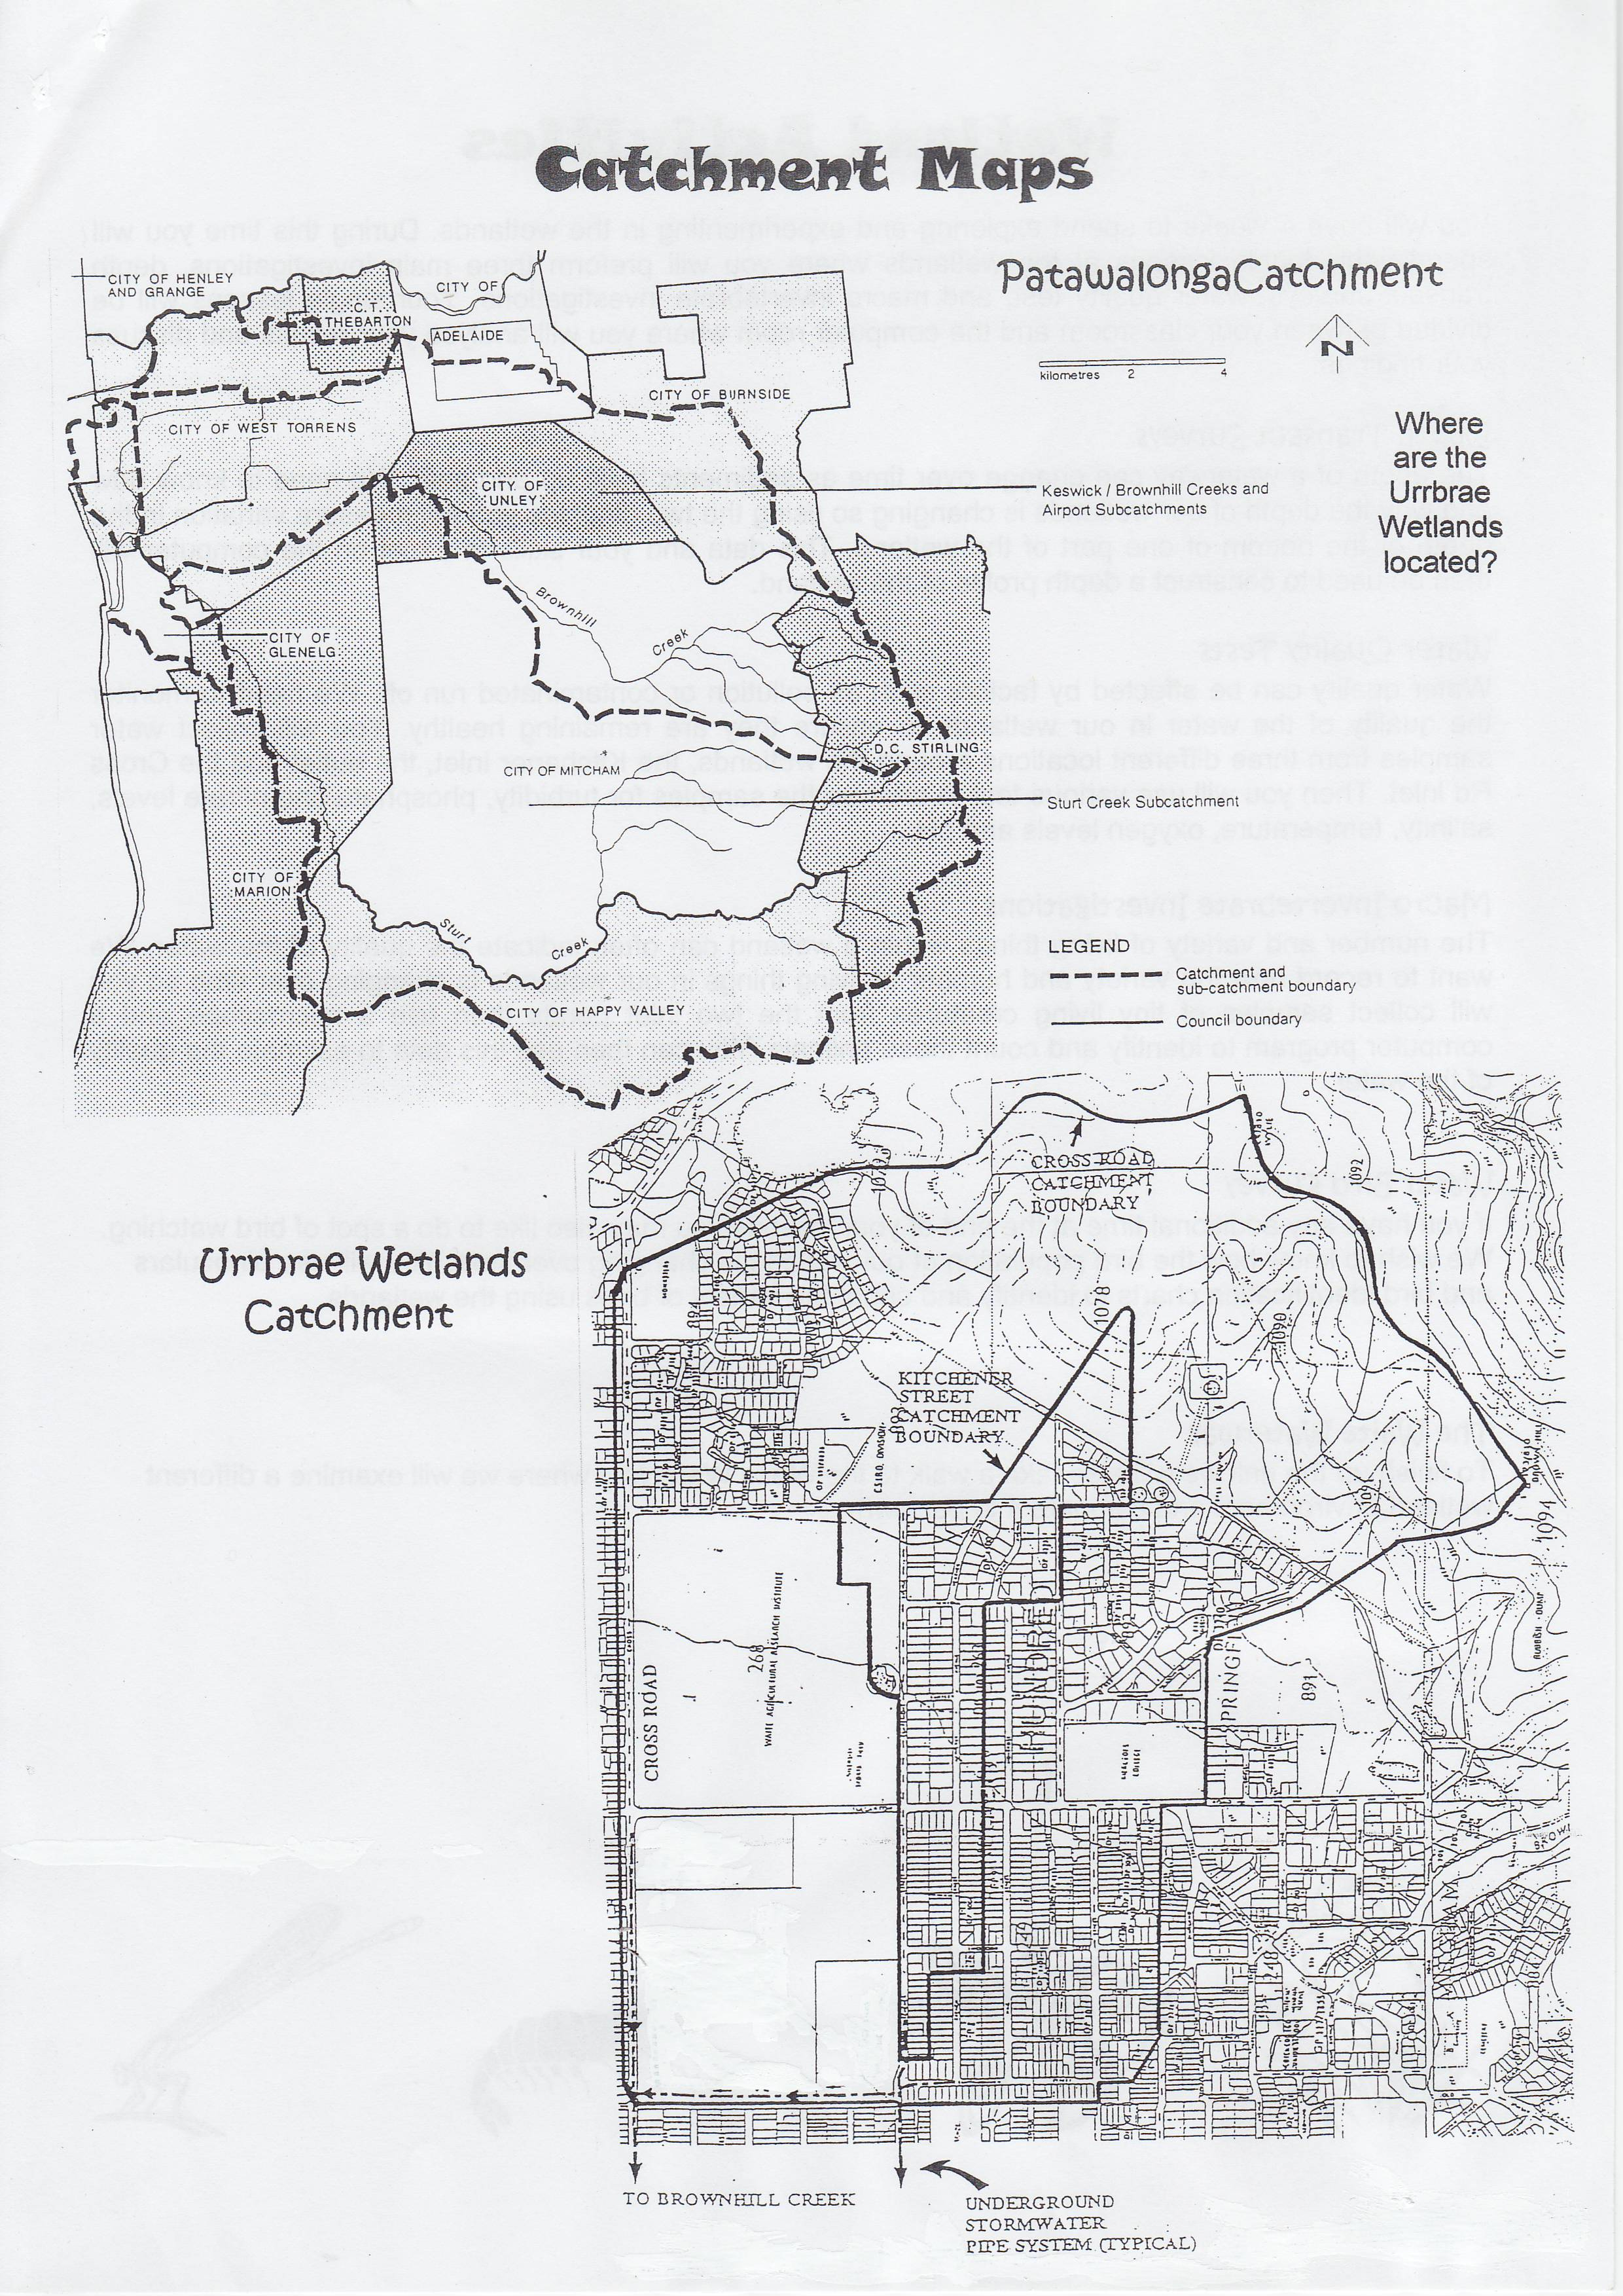

↑

Patawalonga exit to sea.

UAHS

Wetland

Urrbrae

Wetland

Waite

Research

Inst

UH

UAHS