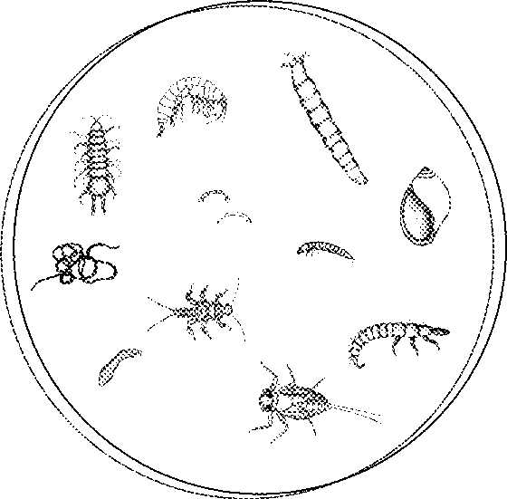Macroinvertebrate Investigation

Most bodies of freshwater are home to **aquatic macroinvertebrates** and the Urrbrae wetland is no exception. These animals include insects, crustaceans, molluscs, arachnids and annelids and they play an important role in wetland ecosystems.

*\\uahs3\apps\OFFICE MEDIA CONTENT\FILES\PFILES\MSOFFICE\MEDIA\CNTCD1\ClipArt2\j0229357.wmfDefine the term aquatic macroinvertebrate and explain why they are important in ecosystems*

Macroinvertebrates are sensitive to different chemical and physical conditions within the water including pollution, oxygen levels and temperature. Some can tolerate a wide range of conditions while others are very sensitive and can only tolerate narrow ranges. As a result we can assign different species **pollution sensitivity rating** and use them as an indirect measure of water quality.

*\\uahs3\apps\OFFICE MEDIA CONTENT\FILES\PFILES\MSOFFICE\MEDIA\CNTCD1\ClipArt2\j0229357.wmf Explain how surveying the macroinvertebrates in the Urrbrae wetland can help us investigate water quality.*

**Your task today is to collect a sample of aquatic macroinvertebrates, identify them and then use your results to indirectly assess water quality and the health of the Urrbrae wetland.**

\\uahs3\apps\OFFICE MEDIA CONTENT\FILES\PFILES\MSOFFICE\MEDIA\CNTCD1\ClipArt3\j0235259.wmf

**Method**

1. Use the nets provided to collect macroinvertebrates from a variety of habitats along the shoreline. **ALL your samples MUST be collected from a SAFE location on a sturdy bank.**
2. Return to the learning centre with your nets and transfer your sample to the water trays provided. Be careful not to tip your nets upside-down until you get back to the learning centre.
3. Use the pipettes and spoons provided to gently transfer as many different types of macroinvertebrate into your petri dish as possible. The petri dish should be no more than half full with water so you may need to remove some of the excess before the next step.
4. Take your petri dish inside and place it under the microscope. Use the key next to your microscope to identify the different macroinvertebrates in your sample. For each type of macroinvertebrate, place a tick next to its name in the results table and record its pollution sensitivity rating.
5. As a group, collate your results and then perform the **signal score** calculations to get an indication of the health of the wetland.

**Signal scores** give an indication of water quality in the area the sample was collected. They are based on the types of organisms that are found and their pollution sensitivity ratings. To obtain a signal score for your results you will need to do a few simple calculations that are set out in the results section.

**\\uahs3\apps\OFFICE MEDIA CONTENT\FILES\PFILES\MSOFFICE\MEDIA\CNTCD1\ClipArt4\j0251195.wmf Results**

|  |  |  |  |  |  |
| --- | --- | --- | --- | --- | --- |
| **Sensitivity** | **Common Name** | **✓ if present** | **Pollution sensitivity** |  | **Not Rated** |
| **Very Sensitive** | Stonefly Nymph |  |  |  | Seed Shrimp |
| Mayfly Nymph. |  |  |  | Copepod |
| Caddisfly Larvae |  |  |  | Waterflea |
| **Sensitive** | Riffle Beetle Larvae |  |  | collembola |  |
| Water Mite |  |  |  |  |
| Marsh Beetle Larvae |  |  |  |  |
| **Tolerant** | Black Fly Larvae |  |  |  |  |
| Crane Fly Larvae |  |  |  |  |
| Pea Shell |  |  |  |  |
| Biting Midge Larvae |  |  |  |  |
| Freshwater Limpet |  |  |  |  |
| Freshwater Prawn |  |  |  |  |
| Little Basket Shell |  |  |  |  |
| Water Strider |  |  |  |  |
| Whirligig Beetle Adult |  |  |  |  |
| Whirligig Beetle Larvae |  |  |  |  |
| Yabby |  |  |  |  |
| **Very Tolerant** | Crawling Water Beetle |  |  |  |  |
| Damselfly Nymph |  |  |  |  |
| Dragonfly Nymph |  |  |  |  |
| Freshwater Shrimp |  |  |  |  |
| March Fly Larvae |  |  |  |  |
| Needle Bug |  |  |  |  |
| Non-biting midge Larvae |  |  |  |  |
| Scud |  |  |  |  |
| Small Water Strider |  |  |  |  |
| Round Worm |  |  |  |  |
| Water Measurer |  |  |  |  |
| Water Scorpion |  |  |  |  |
| Flatworm |  |  |  |  |
| Fishing Spider |  |  |  |  |
| Lsopod |  |  |  |  |
| Hydra |  |  |  |  |
| Predacious Diving Beetle Adult |  |  |  |  |
| Predacious Diving Beetle Larvae |  |  |  |  |
| Segmented Worm |  |  |  |  |
| Soldier Fly Larvae |  |  |  |  |
| Water Boatman |  |  |  |  |
| Water Scavenger Beetle Adult |  |  |  |  |
| Water Scavenger Beetle Larvae |  |  |  |  |
| Backswimmer |  |  |  |  |
| Gilled Snail |  |  |  |  |
| Leech |  |  |  |  |
| Mosquito Larvae/Pupae |  |  |  |  |
| Pouch Snail |  |  |  |  |
| Springtail |  |  |  |  |
|  | **TOTALS** |  |  |  |  |
|  |  | **TAXA RICHNESS** | **POLLUTION INDEX** |  |  |
|  |  | *Number of different macros* | *Total of all sensitivity ratings* |  |  |

**\\uahs3\apps\OFFICE MEDIA CONTENT\FILES\PFILES\MSOFFICE\MEDIA\CNTCD1\ClipArt4\j0251195.wmf Results**

**Describe the patterns you can see in the type of macroinvertebrates present and their pollution sensitivity ratings:**

|  |
| --- |
|  |
|  |
|  |
|  |

**Analysing your results using a signal score**

**Step 1: Calculate your signal score**

Signal Score = Pollution index = =. .

Taxa richness

**Step 2: Use the signal score to estimate the pollution level (circle the appropriate level)**

|  |  |
| --- | --- |
| **Signal Score** | **Pollution level** |
| >5 | Minimal pollution |
| 4-5 | Mild pollution |
| 3-4 | Moderate pollution |
| <3 | Sever pollution |

**Step 3: Use the pollution indicator graph to assess the pollution type**

Use the signal score calculated in step 1 and the taxa richness value from the previous page to plot a point on the pollution indicator graph below. Which quadrant does the Urrbrae wetland fall into?

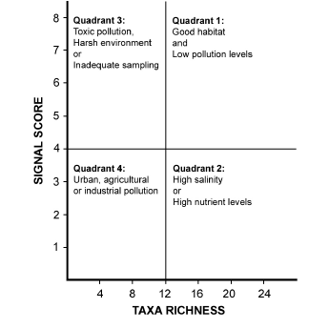

**Describe the level and type of pollution in the wetland:**

|  |
| --- |
|  |
|  |
|  |
|  |

**\\uahs3\apps\OFFICE MEDIA CONTENT\FILES\PFILES\MSOFFICE\MEDIA\CNTCD1\ClipArt3\j0236650.wmfConclusions**

Based on your results, describe the quality of the Urrbrae wetlands water. Include specific examples from your results to justify your response.

|  |
| --- |
|  |
|  |
|  |
|  |
|  |
|  |
|  |

\\uahs3\apps\OFFICE MEDIA CONTENT\FILES\PFILES\MSOFFICE\MEDIA\CNTCD1\ClipArt2\j0229369.wmf

**Questions**

(select the ones relevant to your class and then delete the rest or feel free to add in your own)

* On any given day you may or may not find macroinvertebrates such as Mayfly nymphs or Caddisfly larvae that have high pollution sensitivity ratings. If you don’t find them in a particular sample does this mean the water should be considered polluted? How could you overcome this problem?
* Some macroinvertebrates such as the non-biting midge larvae can tolerate low oxygen levels so would you expect to find them on the surface of the water or the bottom? Explain your answer and discuss why organisms like this are important in a wetland ecosystem.
* What were the main problems you had with the method you used today? How could you overcome these problems?
* When you analysed your results you used the signal score in two different ways (step 2 and step3). Explain which one you though was the most useful and why you believe this.
* Which macroinvertebrate was the most common and which was the least common? Why do you think this is?
* Describe the diversity of macroinvertebrate your group found today. Why is a high level of diversity important in a healthy wetland?
* 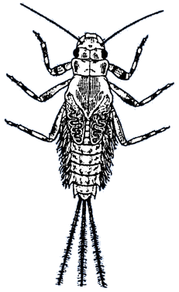Why do you think the seed shrimp, water flea & copepods are not rated in terms of their pollution sensitivities?
* What benefits can you see with using the macroinvertebrates to measure water quality? Use specific examples to back up your response.
* What limitations can you see with using the macroinvertebrates to measure water quality? Use specific examples to back up your response.
* Many macroinvertebrates have different forms during their life cycle. Would you expect to find these different forms all year round and would you expect them to all have the same pollution sensitivity ratings? Explain you answer.