Macroinvertebrate Populations at the Urrbrae Wetland

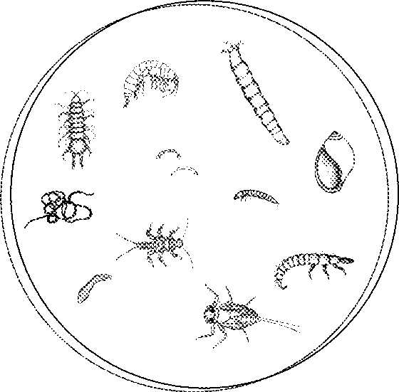The Urrbrae Wetland is a man made wetland designed to retain storm water and prevent flooding in the local area. However, a simple dam could have done the same job but by building a wetland the quality of the stormwater is improved and an environment similar to a natural wetland is created. As a result of this wetland habitat numerous animals now call the Urrbrae Wetland home and they all interact with each other and the wetland to create a unique ecosystem. Your task today is to investigate a group of these animals, known as aquatic macroinvertebrates, and their habitat preferences.

*What are aquatic macroinvertebrates and why are they vital to the ecology of wetlands?*

|  |
| --- |
|  |
|  |
|  |
|  |
|  |
|  |
|  |

*List as many biotic and abiotic factors as you can that might affect the populations of aquatic macroinvertebrates in a wetland such as the Urrbrae Wetland.*

|  |  |
| --- | --- |
| **Biotic factors** | **Abiotic factors** |
|  |  |

Today, you will be investigating the affects of some of these factors on the aquatic macroinvertebrate populations in the wetland. You will be doing this in 6 different habitats types as described below:

|  |  |
| --- | --- |
| Habitat 1 | Inlet pond – deep water with no vegetation cover |
| Habitat 2 | Inlet pond – shallow water with no vegetation cover |
| Habitat 3 | Inlet pond – shallow water with vegetation cover |
| Habitat 4 | Main pond – deep water with no vegetation cover |
| Habitat 5 | Main pond – shallow water with no vegetation cover |
| Habitat 6 | Main pond – shallow water with vegetation cover |

*What comparisons will you be able to make by investigating the aquatic macroinvertebrate populations in these 6 habitats?*

|  |
| --- |
|  |
|  |

**Background**

Due to the number of different factors that can affect this diverse group of organisms it is important to observe as many factors as possible in your testing locations so that you can interpret your results accurately. Record your observations in the space below:

**Climatic conditions**

|  |
| --- |
|  |
|  |

*How could these affect your results?*

|  |
| --- |
|  |
|  |

**Testing location 1 – Inlet pond**

|  |  |  |  |
| --- | --- | --- | --- |
| **Descriptions** | | | |
| Water |  | | |
| Vegetation |  | | |
| In-stream zone |  | | |
|  |  | | |
| **Measurements** | **Habitat 1** | **Habitat 2** | **Habitat 3** |
| Depth |  |  |  |
| Oxygen |  |  |  |
| Temperature |  |  |  |

**Testing location 2 – Main pond**

|  |  |  |  |
| --- | --- | --- | --- |
| **Descriptions** | | | |
| Water |  | | |
| Vegetation |  | | |
| In-stream zone |  | | |
|  |  | | |
| **Measurements** | **Habitat 1** | **Habitat 2** | **Habitat 3** |
| Depth |  |  |  |
| Oxygen |  |  |  |
| Temperature |  |  |  |

*Based on your early observations prepare a hypothesis for this experiment.*

|  |
| --- |
|  |
|  |
|  |

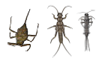**Method**

*What is the independent variable for this experiment?*

|  |
| --- |
|  |

*How will you record or measure it?*

|  |
| --- |
|  |
|  |

*What is the dependent variable for this experiment?*

|  |
| --- |
|  |

*How will you record or measure it?*

|  |
| --- |
|  |
|  |

**Water quality testing**

You will be testing your water samples for phosphates, nitrates, turbidity, salinity, pH, oxygen and temperature using the equipment and instructions provided. What factors do you need to control when doing this section of the experiment?

|  |
| --- |
|  |
|  |
|  |
|  |
|  |
|  |

**Aquatic macroinvertebrate sampling**

You will be collecting and identifying a sample of aquatic macroinvertebrates using the nets and microscope provided. What factors do you need to control when doing this section of the experiment?

|  |
| --- |
|  |
|  |
|  |
|  |
|  |
|  |

**Results**

|  |  |  |  |  |  |
| --- | --- | --- | --- | --- | --- |
| **Habitat .** | | | | | |
| **Water quality** | Result | Interpretation | | | |
| Phosphates  (mg/L) |  |  | | | |
| Nitrates  (mg/L) |  |  | | | |
| Turbidity  (mm) |  |  | | | |
| Turbidity  (JTU’s) |  |  | | | |
| Salinity  (EC’s) |  |  | | | |
| pH |  |  | | | |
| Oxygen  (mg/L) |  |  | | | |
| Temp  (oC) |  |  | | | |
| **Aquatic Macroinvertebrate Diversity** | | | | | |
| Species | | | PSR | Species | PSR |
|  | | |  |  |  |
|  | | |  |  |  |
|  | | |  |  |  |
|  | | |  |  |  |
|  | | |  |  |  |
|  | | |  |  |  |
|  | | |  |  |  |

**Summary of results**

|  |  |  |  |  |  |  |
| --- | --- | --- | --- | --- | --- | --- |
|  | **Habitat** | | | | | |
| **1** | **2** | **3** | **4** | **5** | **6** |
| **Phosphates**  **(mg/L)** |  |  |  |  |  |  |
| **Nitrates**  **(mg/L)** |  |  |  |  |  |  |
| **Turbidity**  **(mm)** |  |  |  |  |  |  |
| **Turbidity**  **(JTU’s)** |  |  |  |  |  |  |
| **Salinity**  **(EC’s)** |  |  |  |  |  |  |
| **pH** |  |  |  |  |  |  |
| **Oxygen**  **(mg/L)** |  |  |  |  |  |  |
| **Temp**  **(oC)** |  |  |  |  |  |  |
| **Diversity**  **(no. of species)** |  |  |  |  |  |  |

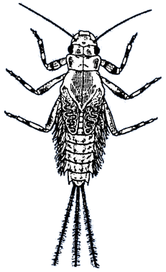**Notes**

|  |
| --- |
|  |
|  |
|  |
|  |
|  |
|  |
|  |
|  |
|  |
|  |
|  |
|  |
|  |
|  |
|  |
|  |
|  |
|  |
|  |
|  |
|  |
|  |
|  |
|  |
|  |
|  |
|  |
|  |
|  |
|  |
|  |
|  |
|  |
|  |
|  |
|  |